LPR GROUND TRANSPORTATION

3455 Azalea Garden Rd

Norfolk, VA 23513

LPR Portal Instruction Manual

Contents

Introduction 3

Snapshot 5

Students 5

Drivers 5

Rides 5

Cancellations 5

Orders 6

New Order API 6

School System- M 6

School Type- M 6

School Name- M 6

First Name - M/Last Name- M/Grade/Gender- M 6

Start Date/End Date- M 6

Additional student 6

Residing Address- M 6

Days needed- M 6

AM Trip 7

PM Trip 7

Parent Details 7

Add-ons 7

Ride along 7

Internal Comment 8

Driver Comment 8

Requested By* 8

Billing* 8

Billable to the client 9

Payable to the driver 9

Tip 9

Manifest 14

Case 1 (Status: Success) 15

Case 2 (Status: No show) 16

Case 3 (Status: Cancel) 16

Case 4 (Operation: Delete Ride) 17

Case 5 (Operation: Cancel All) 17

Billing 18

Client Billing 18

Drivers Bills 21

Ride along Bills 25

Data 28

Schools/Zones/Client 28

Rates 30

Drivers 31

Add Driver 31

Inactive Driver 32

Add trip 32

Advance 33

Advances 34

Ride Along 34

Contact US 35

# Introduction

LPR Ground Transportation is a business providing services in the field of Transportation. The administration maintains documentation of the services provided. LPR portal was designed to digitalize the manual process and make life easy for the administrator. The administrator can add orders, monitor the rides, pay the driver, bill the client and many more using the portal.

This project was designed to work in internal network. The following are the minimal steps required to setup the environment.

1. Install PHP stack. ([Download](https://www.apachefriends.org/index.html))
2. Start the APACHE and MYSQL module in the XAMP control panel.
3. Load the database in the phpMyAdmin (<http://localhost/phpmyadmin/>)
4. Kickstart the system with the URL “<http://localhost/lpr/pages/index.php>”.

Let’s discuss the functionality of the Modules in the API at greater detail followed by the Technical details.

Let’s start with a simple example which illustrates the pivotal functionality of the API.

1. The functionality begins by creating an order for the student. Let’s assume that the administrator created an order in the name of student ‘Chadwick Boseman’ from January 1st to January 10th.
2. On January 1st, admin can see the ride for the student ‘Chadwick Boseman’ at Manifest module. The admin must allocate the driver for the ride for morning and evening trips if not already allocated. Let’s allocate the driver ‘Elizabeth Olsen’.
3. On the day of the ride the admin checks with the driver for the safe destination of the student and updates the Manifest with the status ‘success’. Let’s assume that the admin has updated the manifest similarly from January 1st to January 10th.
4. Now the admin must pay the driver for the trips. He goes to the Drivers API at the Billing Module and selects the driver, dates and verifies the rides for the referred dates. After updating the required fields in the billing sheet, the admin will save the paycheck and print the check for the driver.
5. Next the admin must receive the payment for the ride from the student, in this case the Client.
6. The admin goes to the Schools API at the Billing Module, selects appropriate fields and check the rides. The admin saves the bill and claims the Bill from the client.

Note: The scope of the application is not limited to the above sequential steps.

Let’s dive deep into the modules which follows the above sequential steps at the same time explain to the minute detail about the distinct options available which makes life easy for the admin.

The following are the overall Modules available in the overall LPR transportation system.

1. Snapshot
2. Orders
   1. New Order
   2. Change Order
3. Manifest
4. Billing
   1. Schools
   2. Drivers
   3. Ride along
5. Data
   1. Schools
   2. Rates
   3. Drivers
   4. Ride along
   5. Advances
   6. Stats

# Snapshot

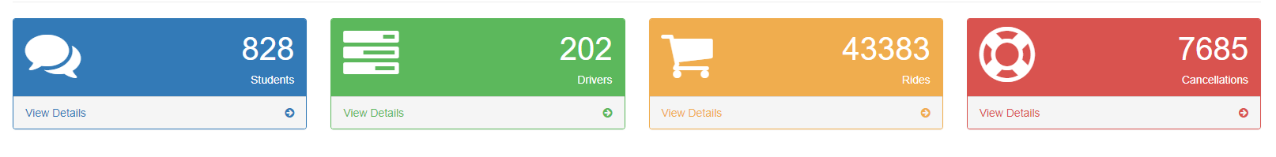

Snapshot module has 4 sections. This module is used to provide information about the statics of the transportation system.

## Students

Students section shows overall count of the Students in the system. The tab will route you to change order API which displays all the orders.

## Drivers

The number of drivers available for the transportation system is available in this section. On clicking the tab, you will be routed to Drivers API.

## Rides

Total rides committed by the transportation system under last 7 days is available in this section. (without considering the ride status). The tab will route you to Manifest API which displays all the orders.

## Cancellations

This section presents information about count of the canceled rides for the last 7 days. The tab will route you to Manifest API which displays all the orders.

# Orders

Orders modules is used to create rides for the clients. Admin while creating a new order for the student/clients takes required details as per the form and submits the order which will later be monitored at the manifest and billed and payed appropriately. The orders will be created at New Order API and can be viewed and edited at Change Order API. Let’s get into detail about the options available in the two API’s.

## New Order API

First, we will go through important options available in the new order followed by the sample order to the end.

### School System- M

Each order will be placed under one school system by selecting one client from the dropdown menu. The number of school systems/clients are limited for now. We can add school systems at

Data 🡪 Schools 🡪 Add Client.

### School Type- M

Each order will be linked to the school type like elementary, Preschool, And Middle.

### School Name- M

The school name dropdown will update automatically based on the School system selected. While Creating the order one should make sure to select the school name.

### First Name - M/Last Name- M/Grade/Gender- M

Details of the student

### Start Date/End Date- M

Select the start date and end date for the transportation to be provided.

### Additional student

By clicking this you will be prompted to enter additional student details. Consider the case where there are more than two students for one order. You have the option even to delete the student in case you have entered details incorrectly.

Even if there are more than one student for one order, billing/payment is done by considering the number of students in the order automatically.

### Residing Address- M

Details regarding student address.

### Days needed- M

Select the days in the week when the client/student require the ride. The client will have rides on the days checked till the end date of the order. The admin can see rides in the manifest only on this checked days.

M- refers mandatory fields

### AM Trip

Trips can be limited for the morning or evening. Check the option based on the requirement. If you check the AM Trip, pickup location will be student address. Click on the filed under *Pickup location*. It will automatically update the pickup address of the student. You have the option to modify the pickup location. *Drop location* will be automatically updated to School location which is the destination of the student for the morning trip.

#### Pickup time

Select the pick-up time of the student by the driver for morning trip.

#### Drop time

Select the drop time of the student by the driver (estimated drop time) for morning trip.

### PM Trip

Select this for the PM trip. For the PM trip the *pick-up location* will be school address and *drop location* will be student address which will be updated automatically if you click on the empty fields.

#### Pickup time

Select the pick-up time of the student by the driver for the evening trip.

### Parent Details

#### First Name-M/ Last Name-M/ Phone-M/ Alternate Phone -M

Enter details of student parents.

### Add-ons

Select additional requirements for the ride. Ride Along and Additional stops have separate charges as observed at Data 🡪 Rates. These charges will be added to billable to the client field.

#### Female Driver Only

#### Ride Along

#### Additional Stop

#### Car Seat

#### Booster Seat

### Ride along

Enter ride along name. Ride along are people who will travel with the students as their support. If the clients require ride along then they must select the ride along option under add-ons and provide name of the person who will act as the ride along. You can add new people for ride along at Data 🡪 Ride along.

You need not enter the name of ride along manually. Just start entering the name and system will automatically pop up all the ride along registered with the name and you can just select one among them.

Ride along will be payed separately at Billing 🡪 Ride along.

### Internal Comment

This comment is added by admin for management purpose.

### Driver Comment

This comment is used to provide information to the driver. Driver comment will appear at scheduling sheets provided to the driver for the trip.

### Requested By*

Requested by will normally be client selected at School system. It can be changed to separate client based on requirement. Billing to the client will be based on the option selected at Requested by.

### Billing*

In-zone: In Zone means the student will go to school under his own zone. This will be represented in the form by selecting the options as observed in the example below.

##### Case 1

1. School system: Norfolk public school
2. Requested by: Norfolk public school
3. Select Billing🡪 In Zone
4. Click calculate

Now the order is Billable only to Norfolk public school. Total bill: 28.42$ (Norfolk, In Zone price, No add-ons, check rates at Data🡪 Rates)

##### Case 2

1. School system: Norfolk public school
2. Requested by: Norfolk public school
3. Select Billing🡪 In Zone
4. Select Billing 🡪 Wheel Chair
5. Click calculate

Now the order is Billable only to Norfolk public school and the bill will be different than the case 1 since the bill changes by selecting the wheel chair option. Total Bill: 15$ (Norfolk, Wheel chair-In zone price, No add-ons, check rates at Data 🡪 Rates.)

#### Out Zone:

In Out Zone the student will belong to one zone and will go to school present in different zone. This will be presented in the form by selecting the below options.

##### Case 1

1. School system: Norfolk public school (student goes to this school at different zone)
2. Requested by: Portsmouth Public Schools (student belongs to this zone)
3. Select Billing🡪 Out Zone
4. Check Portsmouth Public Schools, Norfolk public school
5. Click calculate: Total Bill 42 (Out zone Norfolk + Out zone Portsmouth Price, No add-ons)
6. Now the total bill must be divided between Norfolk public schools and Portsmouth public schools. Enter the amount at the fields present at step 4 manually. In case you don’t want to Bill to one of the clients enter the amount as 0 for one of the clients and the total bill to the other.

##### Case 2

1. School system: Norfolk public school (student goes to this school at different zone)
2. Requested by: Portsmouth Public Schools (student belongs to this zone)
3. Select Billing🡪 Out Zone
4. Select Billing🡪 Wheel chair
5. Check Portsmouth Public Schools, Norfolk public school
6. Click calculate: Total Bill 45 (Out zone, Norfolk, wheel chair + Out zone, Portsmouth, wheel chair Price, No add-ons)
7. Now the total bill must be divided between Norfolk public schools and Portsmouth public schools. Enter the amount at the fields present at step 5 manually. In case you don’t want to Bill to one of the clients enter the amount as 0 for one of the clients and the total bill to the other.

By default, the orders will In Zone. The admin must understand how to divide the bills in the case of out zone. In short, in the case of Out zone split the bills manually and clients will be billed as such.

### Billable to the client

Click calculate. The system will consider the add-ons, In Zone or Out Zone options selected and bill to the client. You can even modify the bill manually.

#### Driver

Enter the driver name for the AM trip. You can leave the field empty if you didn’t decide on the driver.

#### Add PM Driver

Enter the driver name for the PM trip. You can leave the field empty if you didn’t decide on the driver.

### Payable to the driver

Enter the amount payed to the driver for the trip manually. This will be used for driver payment.

### Tip

Enter the tip payed to the driver for the trip manually. This will be used for driver payment.

Example form Out Zone

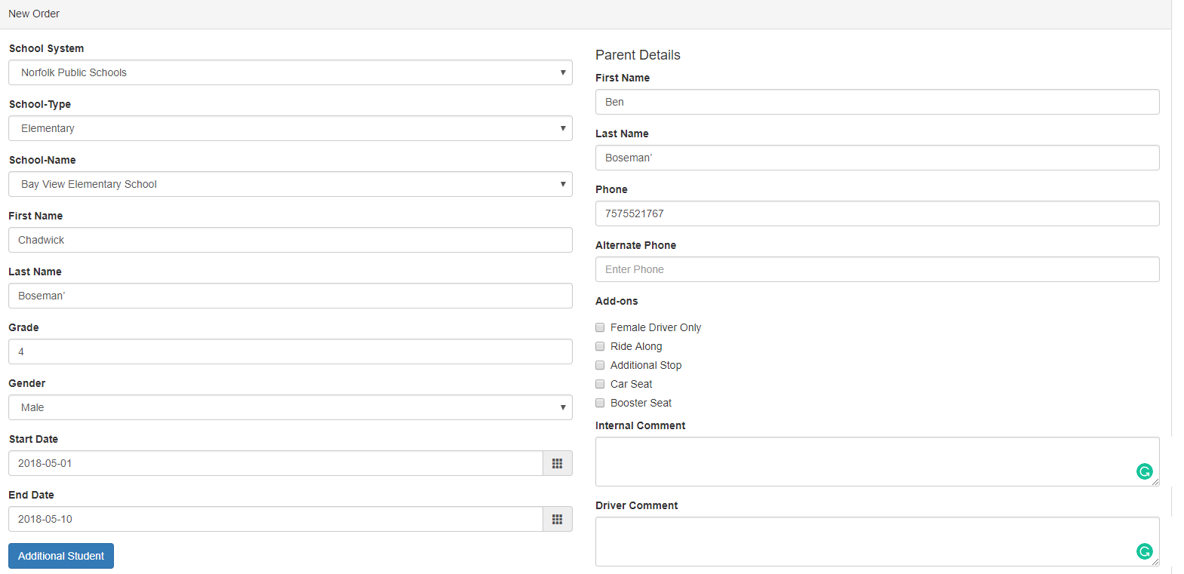

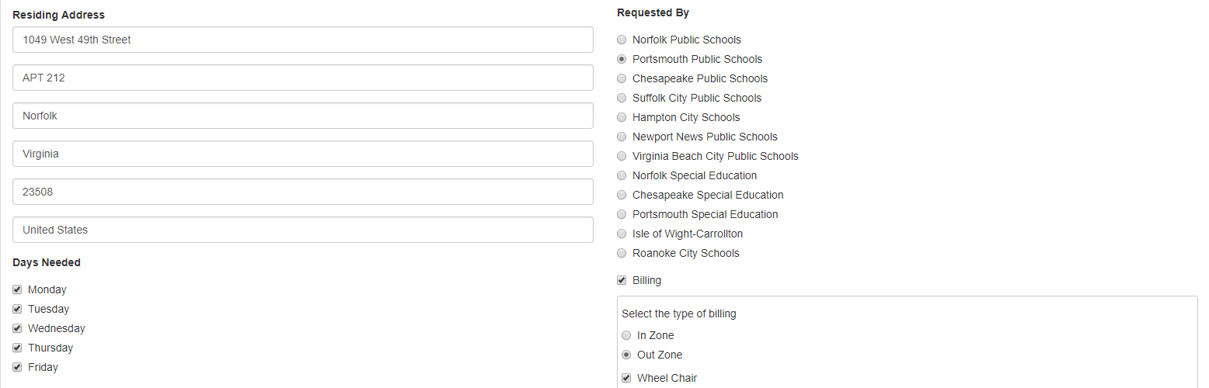

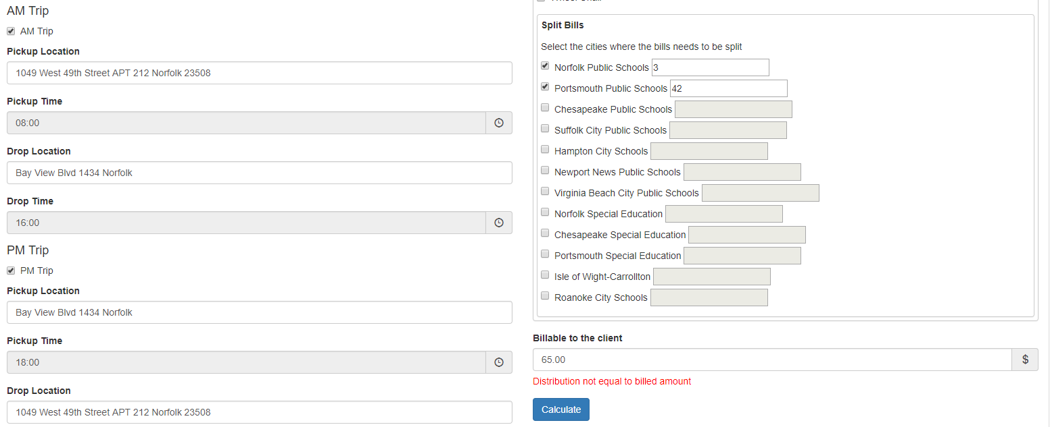

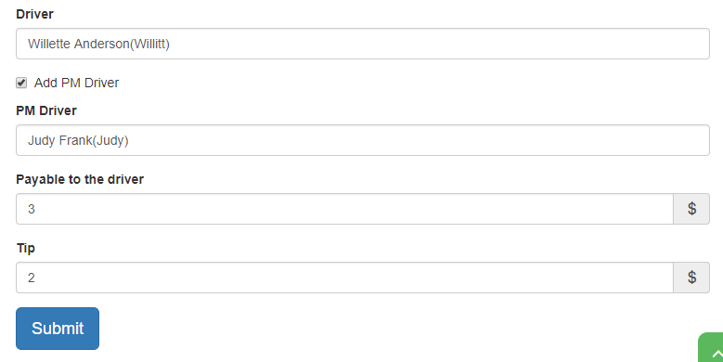

Example form for In Zone

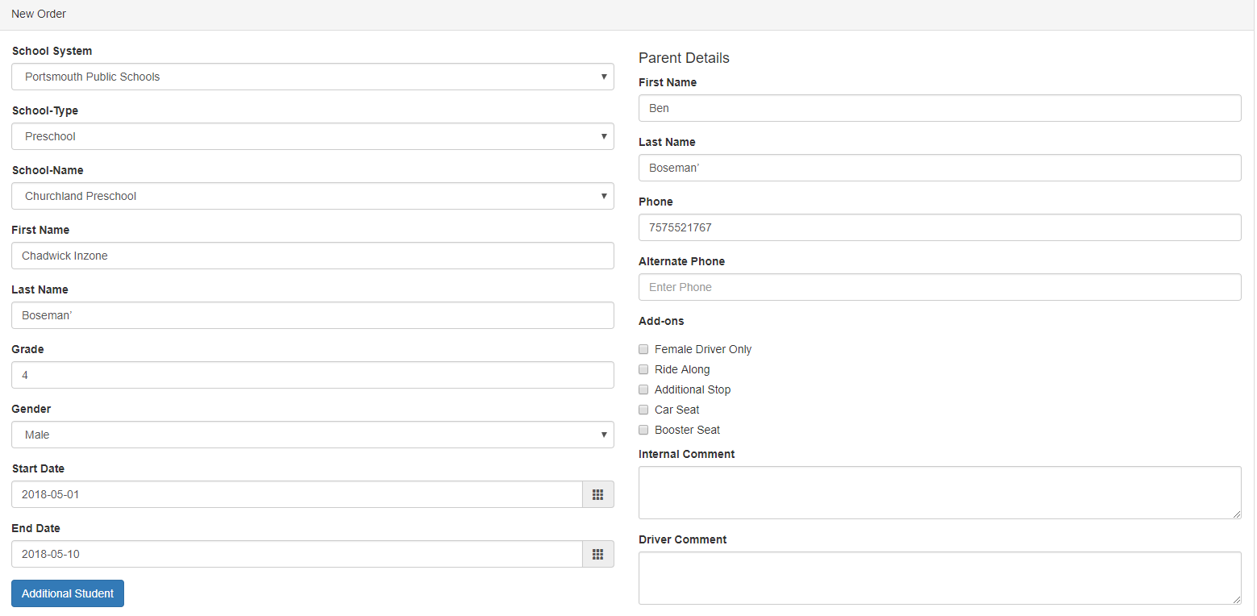

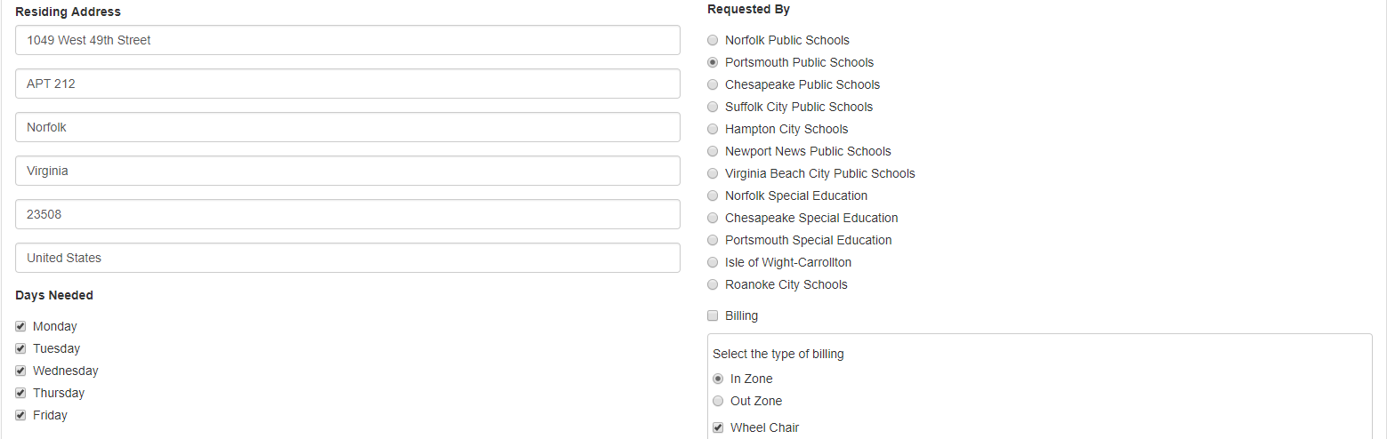

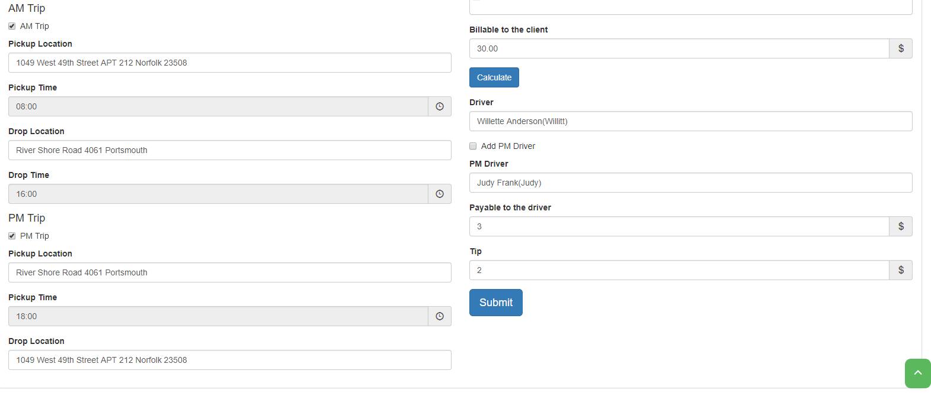

# Manifest

Manifest is used to allocate daily rides for the drivers. Let’s understand the use of Manifest with simple example followed by different case studies about how to use Manifest.

A student with name ‘Chadwick Boseman’ has order for ride from 1st to 10th May. First on the day of ride, the admin must print the contractor sheet and issue it to the driver ‘Willette Anderson’ which is the way of allocating the ride for the driver to pickup the student ‘Chadwick Boseman’. Next the admin must go the student record in the manifest.



The initial status for the ride will be pending. Now the admin must call the driver, Willette Anderson or the driver calls the admin and updates the status of the ride. If the ride is success the admin will update the status from pending to success and update the pick-up and drop-off time as required. To update the status the admin must click on the 2 red clocks as observed above. On click of each clock it will update the current time automatically. The admin has the privilege to edit the timings by clicking on the edit button. Similar things need to be done for AM and PM.



## Case 1 (Status: Success)

Let’s assume that the admin has issued the contractor sheets to all the drivers in the morning by using print contractor sheets option.



PAX: Number of passengers for the ride.

Other columns are self-explanatory

|  |  |
| --- | --- |
| Initial Status | Pending |
| 1st- Call | Admin receives the call from driver and receives information about pick-up. |
| Update- Pickup Time | Admin clicks the red clock at the pickup time. Current time updates automatically. Color of clock changes to green |
| 2nd- Call | Admin receives the call from driver and receives information about the drop. |
| Update- Drop off Time | Admin clicks the red clock at the Drop off Time. Current drop off time updates automatically. Color of clock changes to green. Status changes from pending to Success. |
| Edit | If admin needs to update the information about the ride, he should click edit and perform the update operation of the ride and then click save. Admin can edit Time, Driver Name, Pick up time, Drop Off time. |

* Similar steps for PM trips *

## Case 2 (Status: No show)



|  |  |
| --- | --- |
| Initial Status | Pending |
| 1st- Call | Admin receives the call from driver and receives information about pick-up. Drivers informs that the student didn’t turn up to the ride. |
| No show | Admin clicks the ‘No show’  button. Status updates to ‘No show’    *Zoom in* |
| Edit | If admin needs to update the information about the ride, he should click edit and perform the update operation of the ride and then click save. Admin can edit Time, Driver Name, Pick up time, Drop Off time. |

* Similar steps for PM trips *

## Case 3 (Status: Cancel)



|  |  |
| --- | --- |
| Initial Status | Pending |
| 1st- Call | Admin receives the call from student or client about the ride cancellation for one particular day. |
| Cancel | Admin clicks the ‘Cancel’  button. Status updates to ‘Cancelled’ for the selected day.    *Zoom in* |
| Edit | If admin needs to update the information about the ride, he should click edit and perform the update operation of the ride and then click save. Admin can edit Time, Driver Name, pick up time, Drop Off time. |

* Similar steps for PM trips *

## Case 4 (Operation: Delete Ride)



*Status: No show, Success, Cancelled

|  |  |
| --- | --- |
| Initial Status | Success, No Show, Cancelled |
| Delete | Admin clicks the delete button. The ride goes back to the initial status of pending. |

* Similar steps for PM trips

## Case 5 (Operation: Cancel All)

* Click the ‘Cancel All’ button

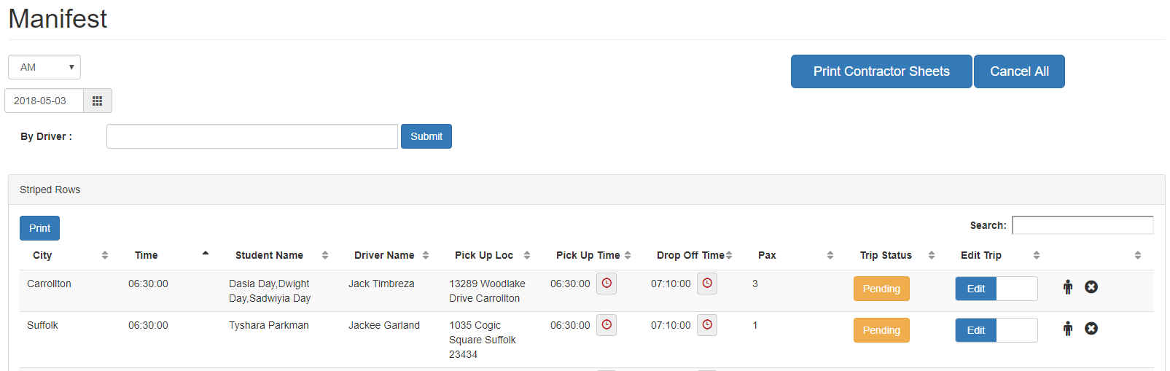

* A pop will ask you to confirm the operation. If you confirm all the operations will be updated to ‘Cancelled’ status.

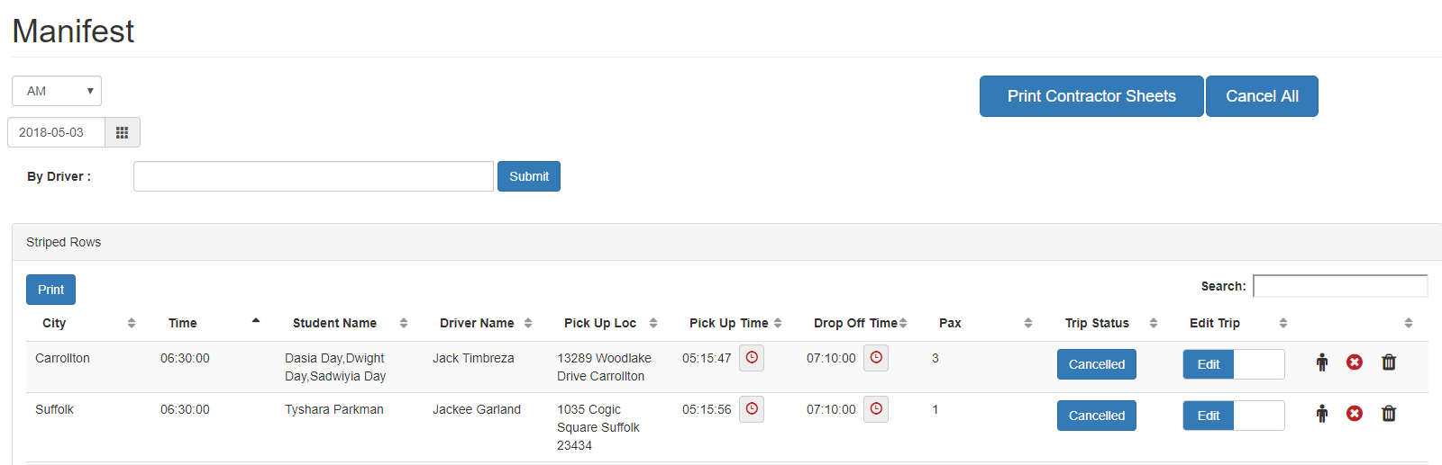

* Similar steps for PM trips

# Billing

After the successful rides in the manifest, the admin has to pay the drivers, ride along and bill the clients for the rides. Billings API provides an option to perform this tasks independently. The admin has the option to Save, Edit and Delete the bills, pay checks.

## Client Billing

To bill the clients the admin has to use the filters in the client billing API and select required options and submit the request.

Step 1

Observe the successful ride in the manifest. The client for the trip is Portsmouth public school. The ride is observed on May 1st by the driver Timbreza Jack.



Step 2

To pay the client ‘Portsmouth public school ‘, Select filters in client Billing API fill appropriate details as observed below and click submit

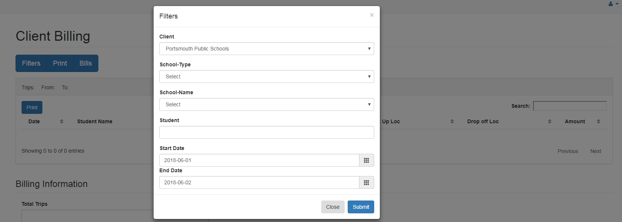

Step 3

Client Bill appears on the screen. Click Save to Payroll button.

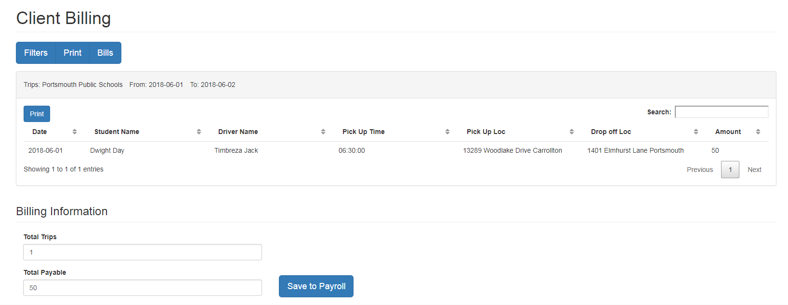

Step 4

Click print. Print/Save the invoice

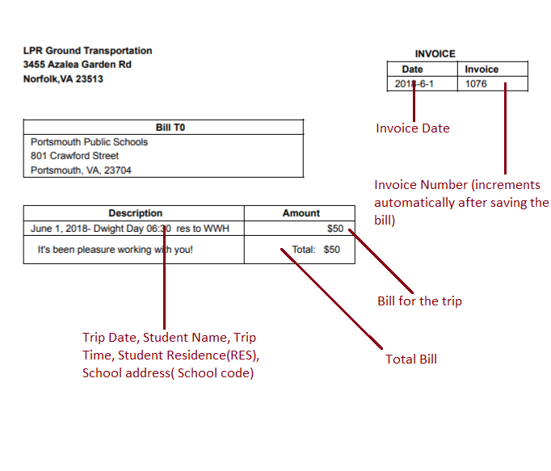

Step 5

We can Edit or Delete the bills from Bills menu. Click Bills

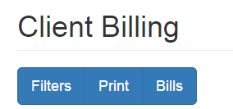

Step 6

Select the client to Edit/ Delete the bills as observed below and click submit.

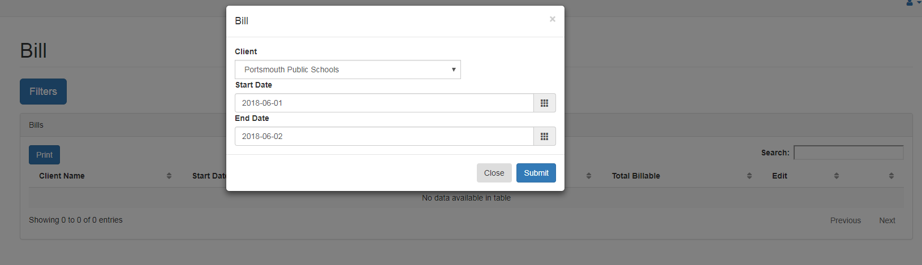

Step 7

All the bills for the selected date range will appear on the display. You can Edit/Delete the bill here.

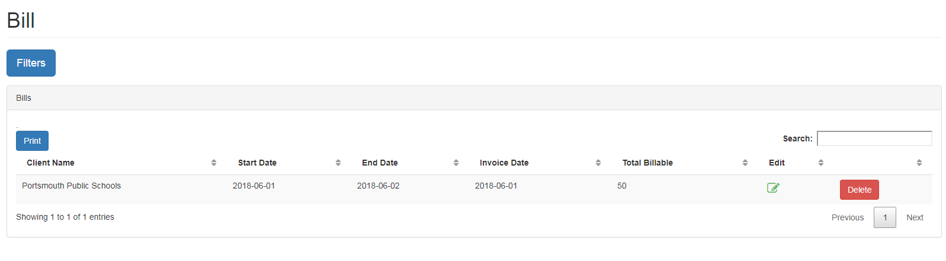

## Drivers Bills

To pay the driver ‘Timbreza Jack’ for the trip follow the steps below.

Step 1

Trip in the manifest.



Step 2

Select filters and fill details as observed below. Click Submit

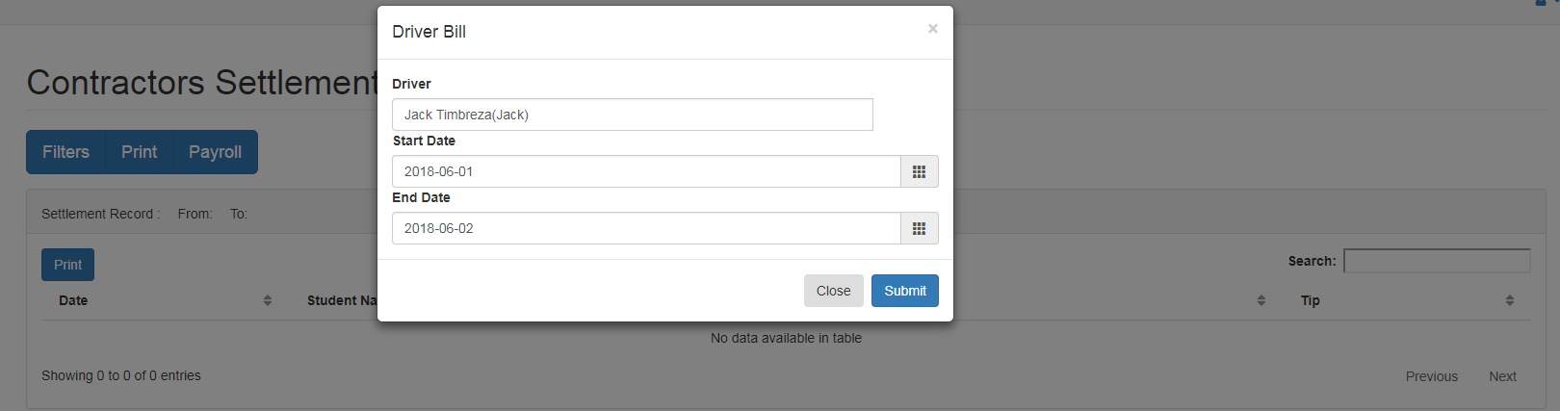

Step 3

Observe the Contractor Settlement sheet and fill appropriate details to save/print the bill. Click calculate and Save the Payroll. You have the option to print the payroll, Edit/Delete the payrolls, and print the checks to the Driver/ Contractor

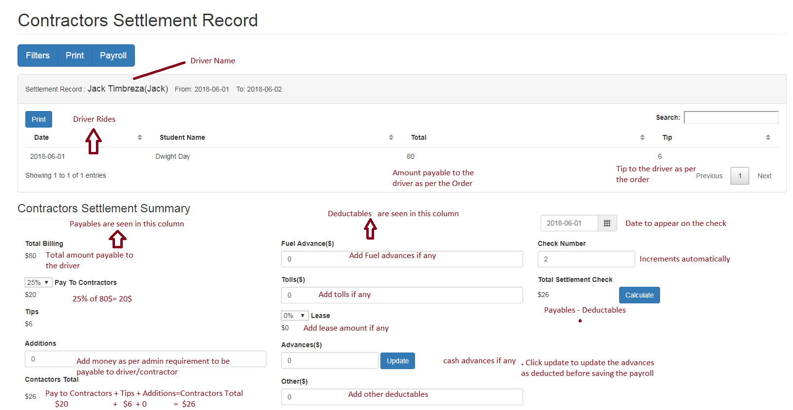

Step 4

Print the Payroll

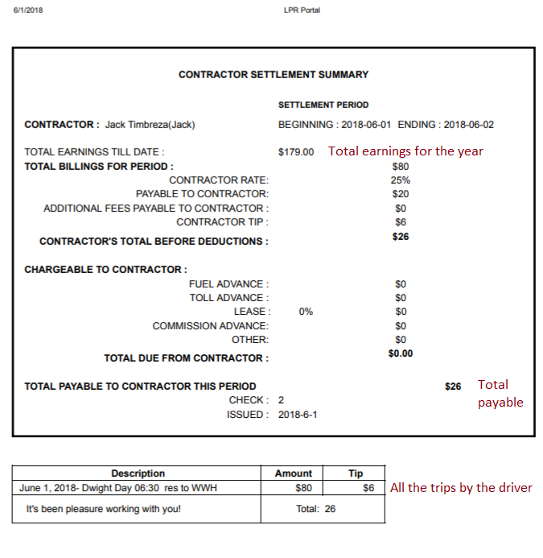

Step 5

To print the checks to the drivers after saving the payroll click payrolls and fill details as observed below.

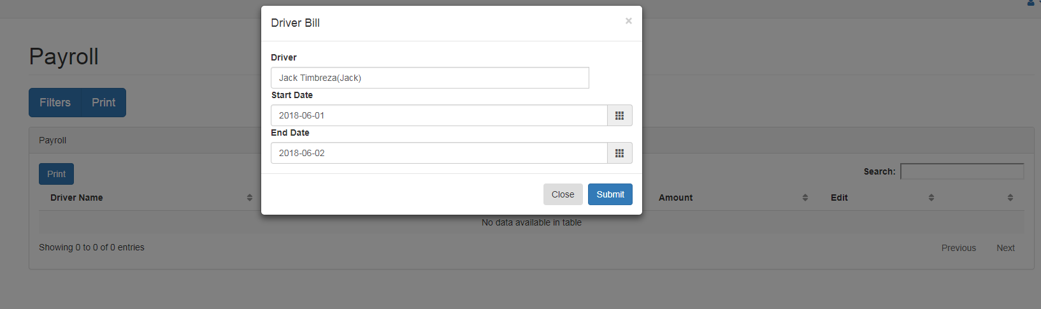

Step 6

Payrolls saved for the driver appears on the display. Click print to print the check. Edit/ Delete the payroll as required

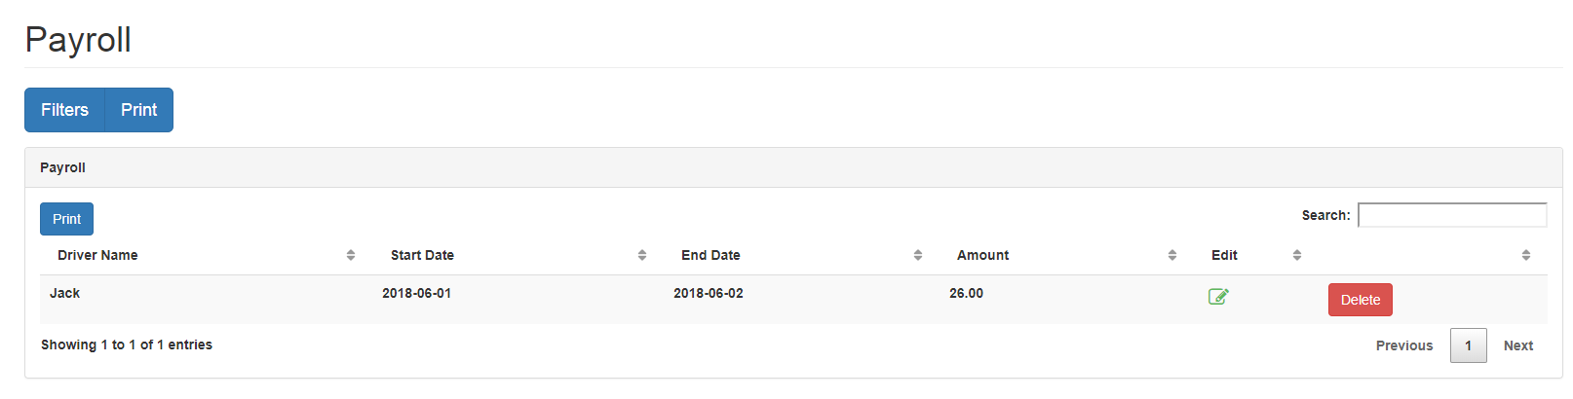

## Ride along Bills

The admin has the option to Monitor the rides, save the payrolls, Edit/Delete the payrolls, and Print the checks to the ride alongs. This module is similar to the Driver billing scenario.

Step 1

For the trip below the Ride along Person is Lawrence Padgett as per the information in the order.

Manifest Trip



Step 2

Click Filters and enter details as observed below. Click Submit

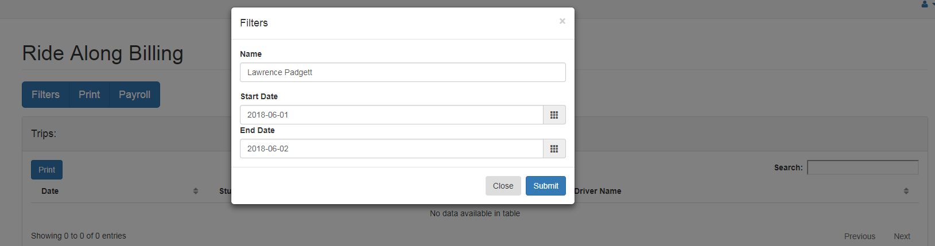

Step 3

Observe the trips and information provided. Edit if required. Click Calculate. Click Save to Payroll.

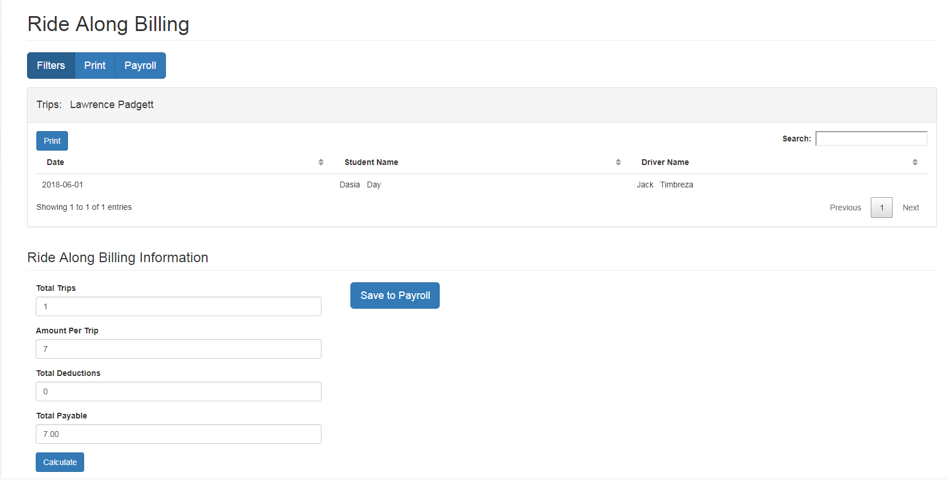

Step 4

Click Print to print the payroll details.

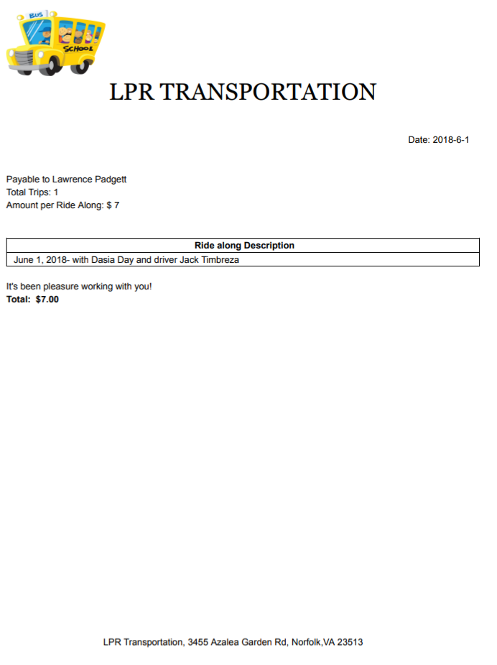

Step 5

To print the checks click Payroll.

Enter the information as observed below. Click submit

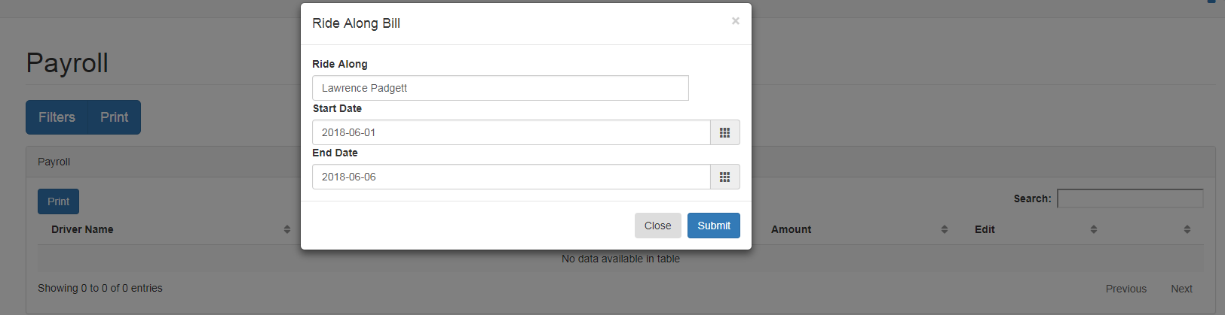

Step 6

Click Print to print the check. Edit/ Delete the payroll as required.

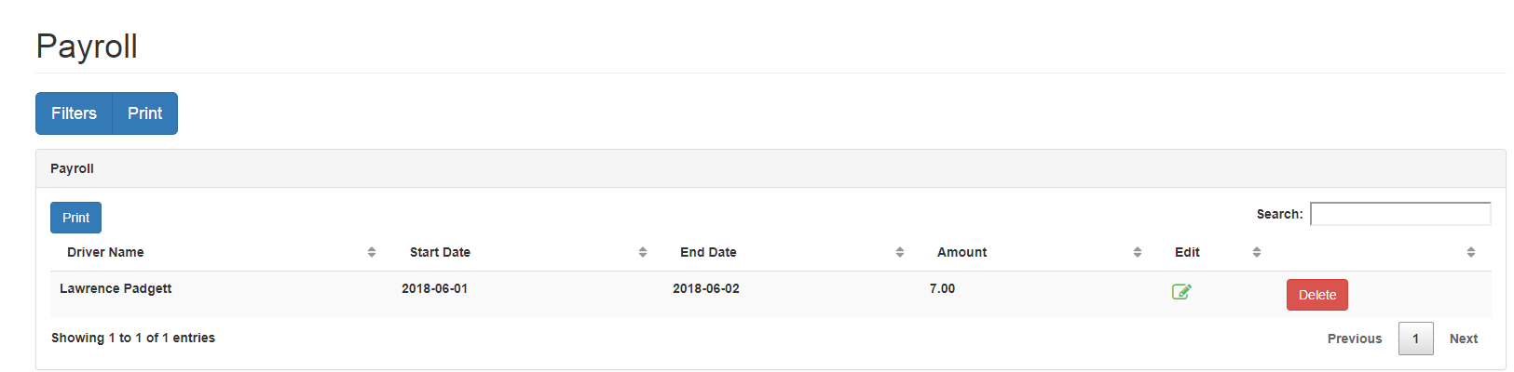

# Data

The data API provides an option to add information into the system. We can Add/Edit Zones, Clients, Rates, Drivers, Ride Along and Advances.

## Schools/Zones/Client

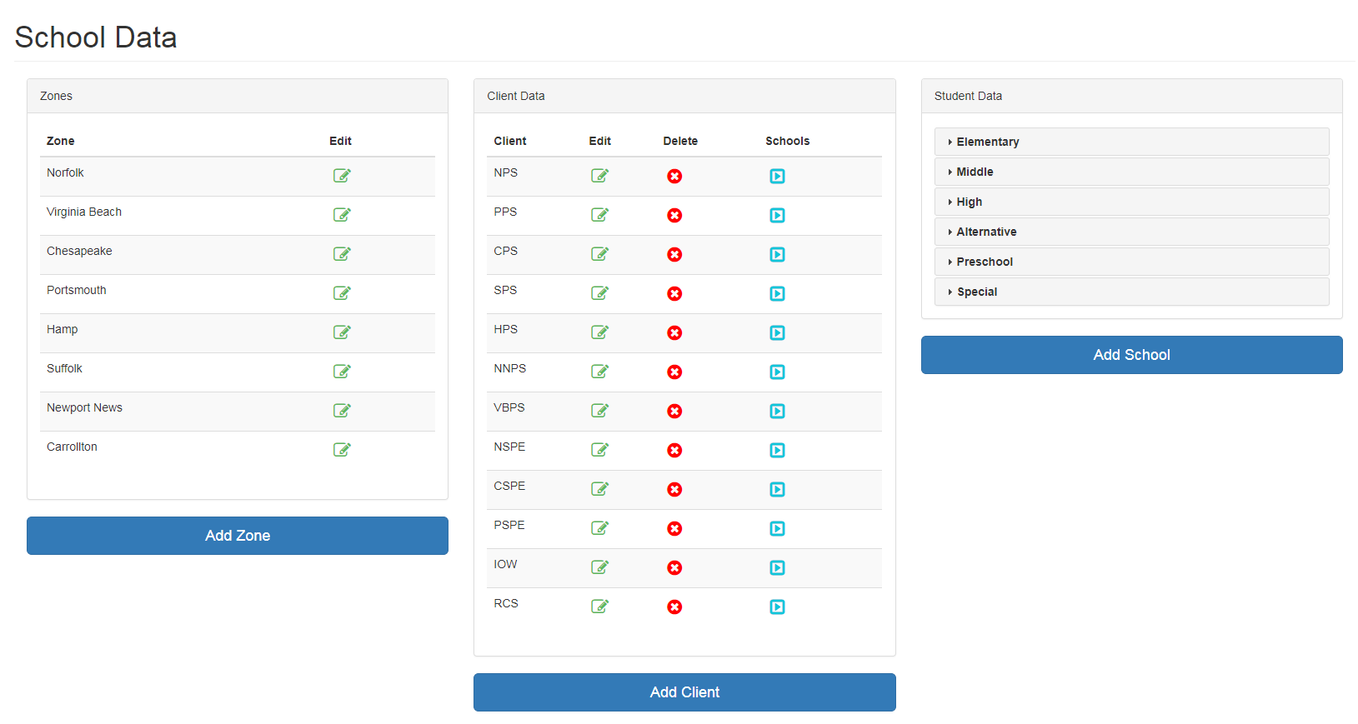

From school API we can add/edit Zones, Clients, and School. Each Client belongs to one Zone. Each school belongs to one Client. The forms are self-explanatory.

To edit schools click image on the screen as observed below.

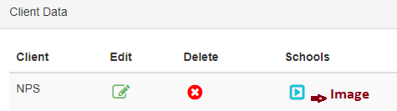

Second click on School types as observed below.

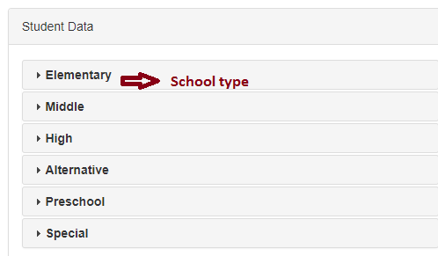

After clicking on school type it opens up a drop down as observed below. Click the edit button and edit the school information.

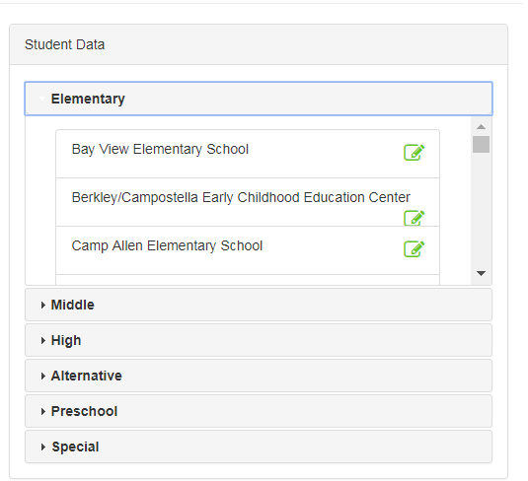

## Rates

Observe the prices variation for the Zones, Add-ons in this screen. You have the option to edit the prices.

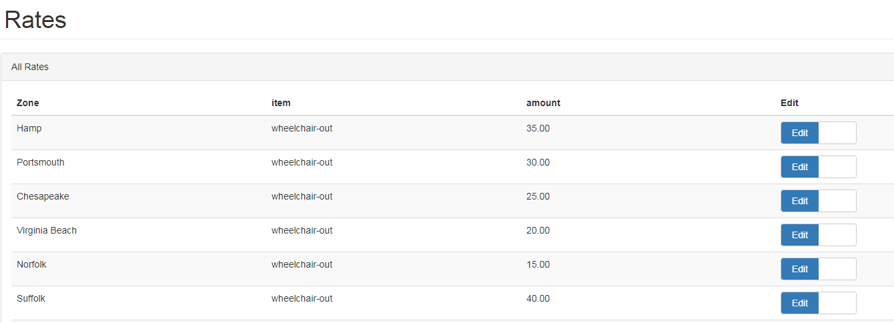

## Drivers

From the drivers API we can add/edit/add trips/activate/deactivate drivers.

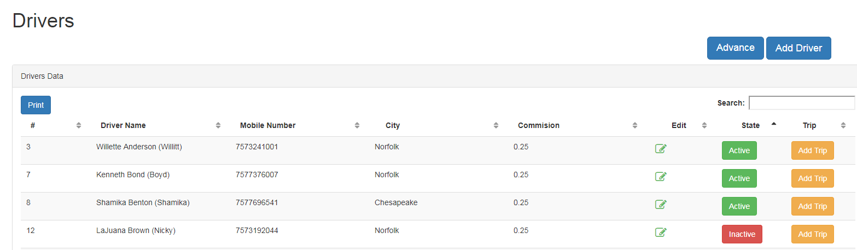

### Add Driver

To add driver click add driver button on the screen. Enter required information and click submit button.

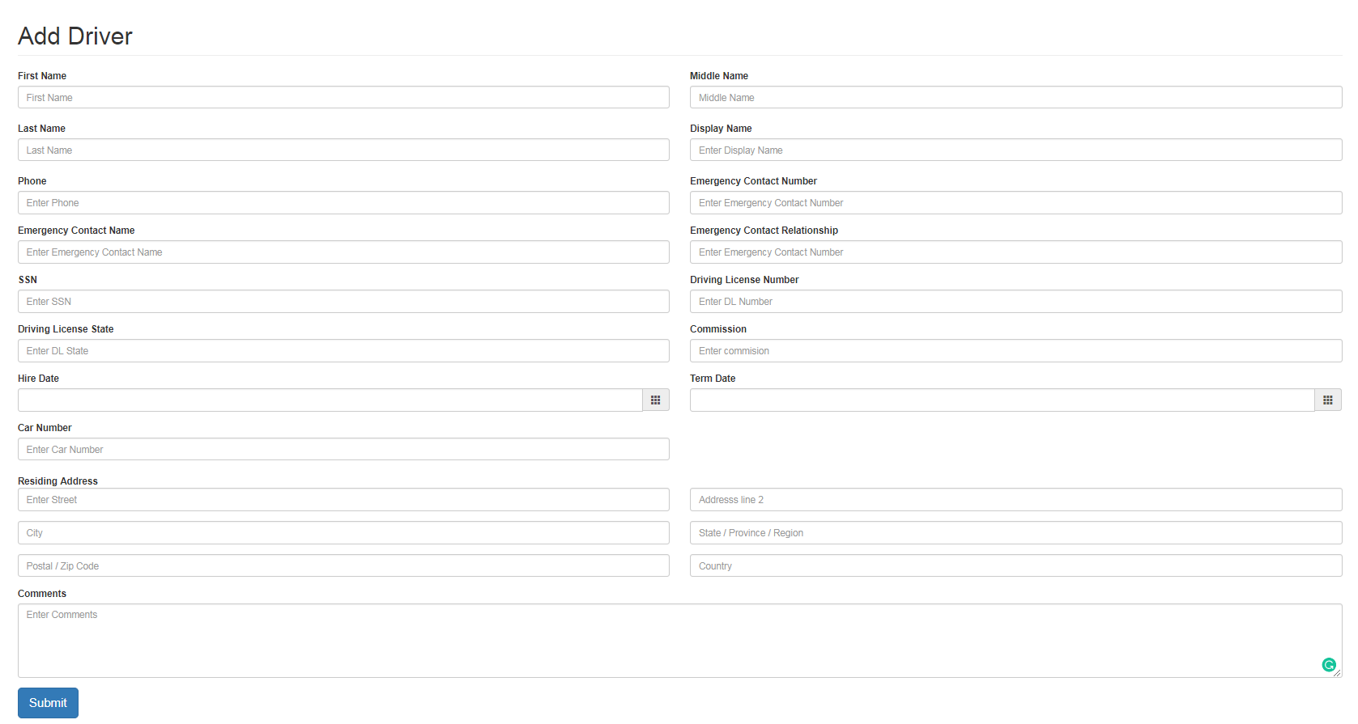

The driver information will appear in the screen as below. We can the edit the information of the driver by clicking the edit button.



### Inactive Driver

To deactivate the driver click the active button. The driver will be inactive and the system will not allow the driver for the rides.



### Add trip

The admin can add trips to the driver which would reflect in the payable information of the driver and in the billing of the client. Click the add trip button corresponding to the driver.



Fill the details below. Enter the amount payable to the driver and tip as per the admin requirement. The amount billable to the client will be taken from the order based on the student selected. Check the button to NO if you don’t want to pay the client/driver for the trip. The trips added here will be reflected in the driver payables and client bills as ‘Additional trips’

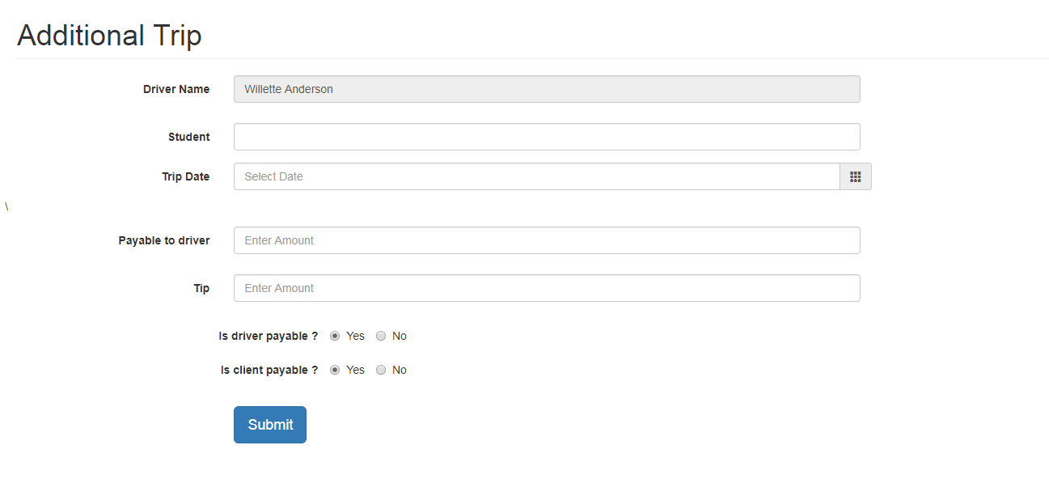

### Advance

Click the advance button. Add the driver name and Cash advance provided to the driver. Click submit button.

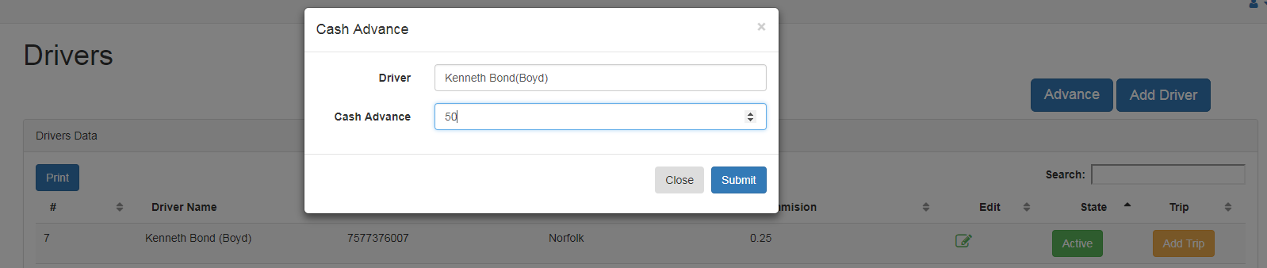

This amount will be reflected in the driver billing under deductibles as below

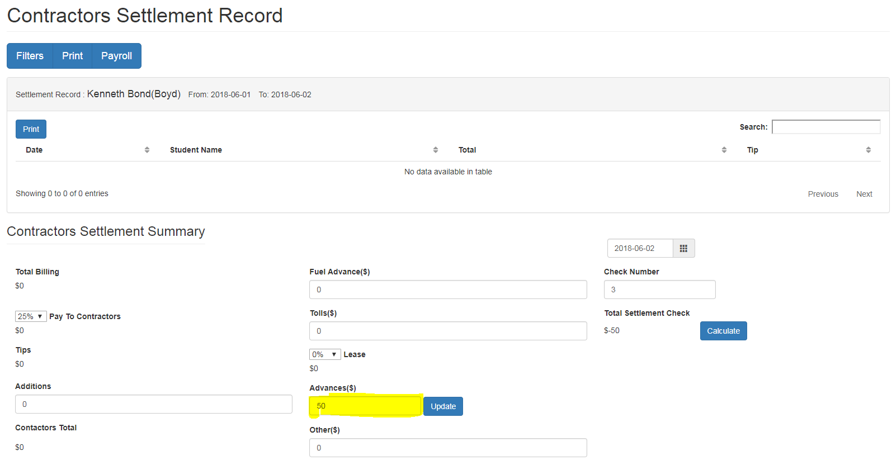

If you click the update button above for advances what it means is that the driver has given the amount back to the admin and the screen reflects as data updated as seen below

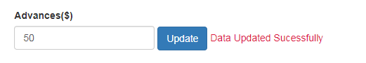

Now for the next time when you search for the same driver (at driver payable screen) you will see that the advances will be 0 since he has given back the amount to the admin.

All this transactions related to advances can be seen in the Advances screen.

## Advances

To check the transactions related to the Cash advances made above click advance and select the driver from the filters.

The transactions will appear as below. You have an option to print/delete the transaction as seen below.

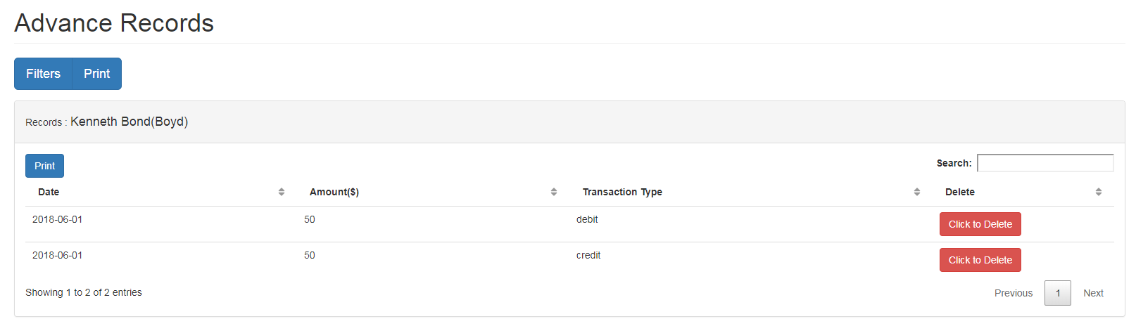

## Ride Along

Here admin has the provision to add/edit ride along information. The forms are self-explanatory.

# Contact US

For information regarding LPR Portal please contact

*Karthik Navuluri*

Assistant Director, Web, Portal & Mobile

Information Technology Services

1114 MONARCH HALL

NORFOLK, VA 23529

Email: knavulur@odu.edu